S IS FOR STAIRS

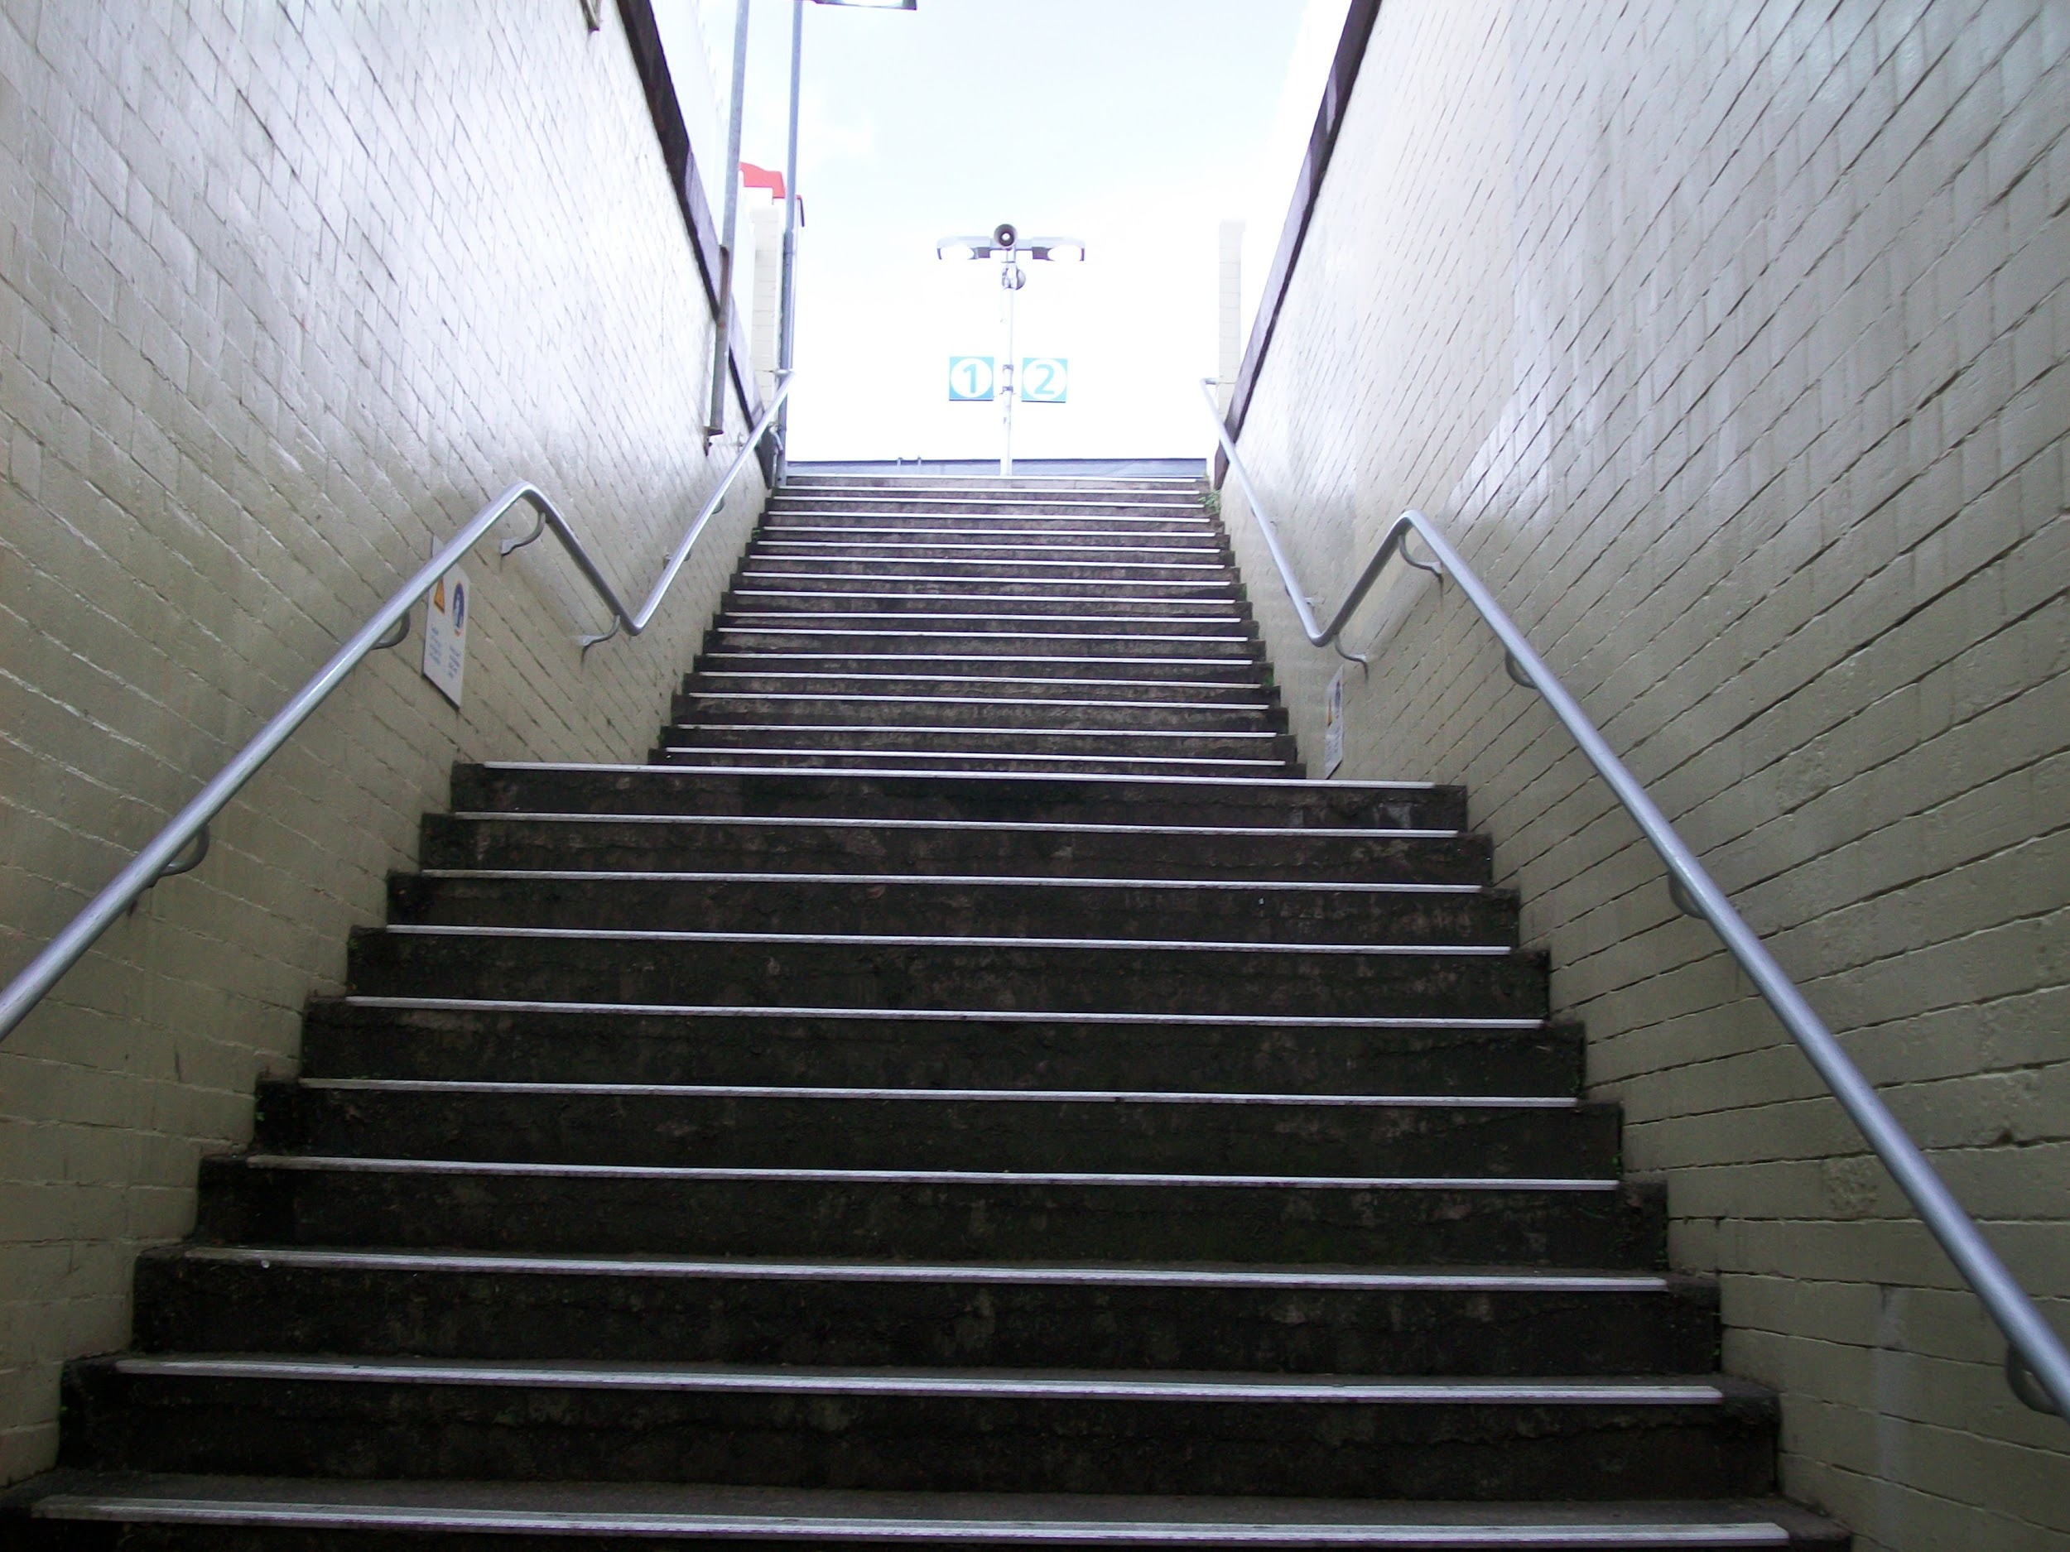
S s

Six stairs for stepping up to Susie’s doorstep.
Such a simple exercise!

_____________________________________
_ _ _ _ _ _ _ _ _ _ _ _ _ _ _ _ _ _ _ _ _ _ _ _ _
_____________________________________
_____________________________________
_ _ _ _ _ _ _ _ _ _ _ _ _ _ _ _ _ _ _ _ _ _ _ _ _
_____________________________________
S S S S
s s s s
Trace and write the letters

