R is for rain

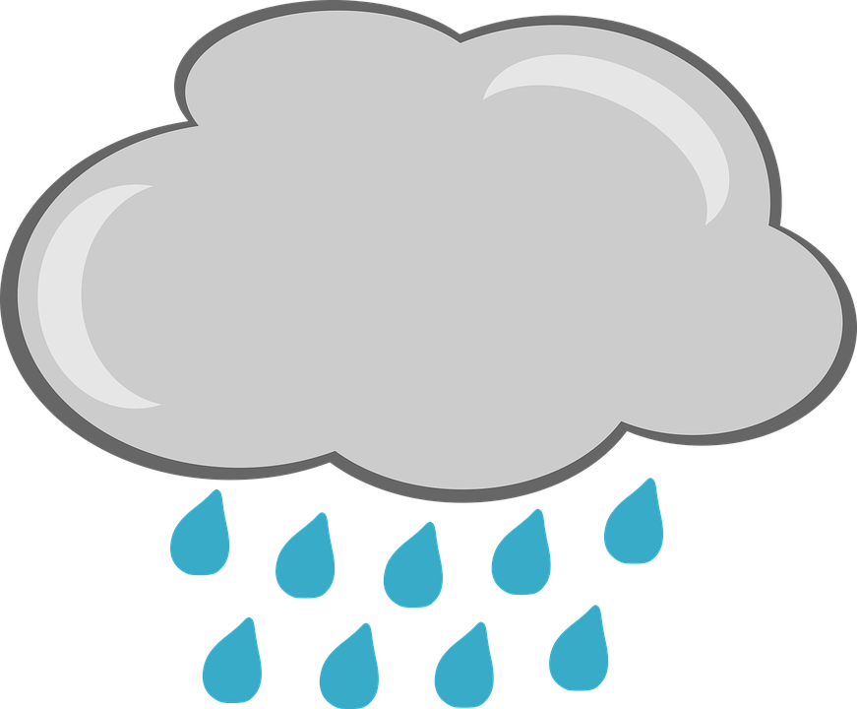
R r

Rain, rain, rain, rainbow!
Run right up and reach the red.
Is the rainbow real? Can you reach the red?

_____________________________________
_ _ _ _ _ _ _ _ _ _ _ _ _ _ _ _ _ _ _ _ _ _ _ _ _
_____________________________________
_____________________________________
_ _ _ _ _ _ _ _ _ _ _ _ _ _ _ _ _ _ _ _ _ _ _ _ _
_____________________________________
R R R R
r r r r
Trace and write the letters

