Planting and Growing!
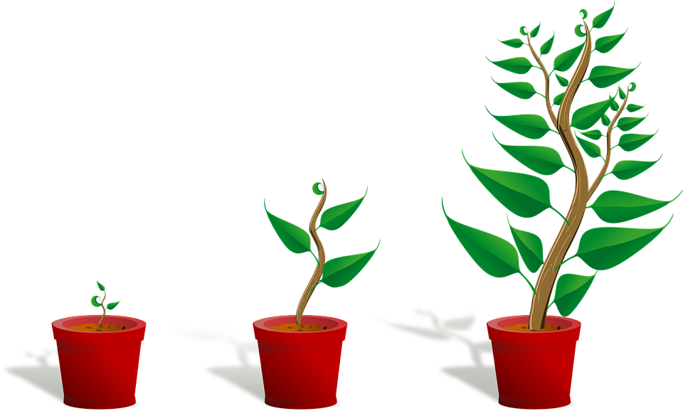
Draw a plant with roots!

My plant has _________________
__________________________.

