Mud and Dirt!

Draw mud all over the person!
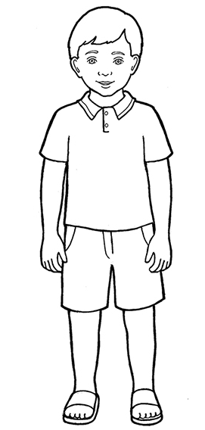

Where is the mud? There is mud __
___________________________________________________

